Use-Case Realization Report
AddRole

Issue <1.0>
Revision History
Date | Issue | Description | Author
<02/08/09> | <1.0> | <Add Role> | <Karen Gao>

Table of Contents
1. Brief Description 4
2. Flow of Events 4
2.1 Standard Flow 4
2.2 Exceptions 4
3. Interaction Diagrams 5
3.1 Collaboration Diagram for AddRole 5
4. Participating Objects 5
5. Class Diagrams 6
5.1 Class Diagram for AddRole 6
6. Derived Requirements 6

Use-Case Realization Report
AddRole

Brief Description
This describes the addition of the Role and the necessary check that the entry is no duplicated before confirming the addition.

Flow of Events

Standard Flow
This use case covers the events of adding the Role, which is part of the customer maintenance package. The standard flow of events is described as below:
- The Portal Administrator shall press the button to send out a command of “AddButtonClicked” on the interface of MaintainRolePage.
- The operation checkRoletoAdd will check for the duplication based on the reference from the role list retrieved by the operation getRoleList.
- The RoleController will select the DAP through the operation getDAPList and showDAPList to the interface of MaintainRolePage.
- The RoleController will then select FAP through the operation getFapList and showFAPList to the interface of MaintainRolePage.
- A role is created through the operation createRole, and RoleController will add it into the role list through the operation addRole to the object of Role.

Exceptions
- If there’s duplication of role is found, a message will be sent to MaintainRolePage through the operation showRoleDuplicatedMsg.

Interaction Diagrams

Collaboration Diagram for AddRole
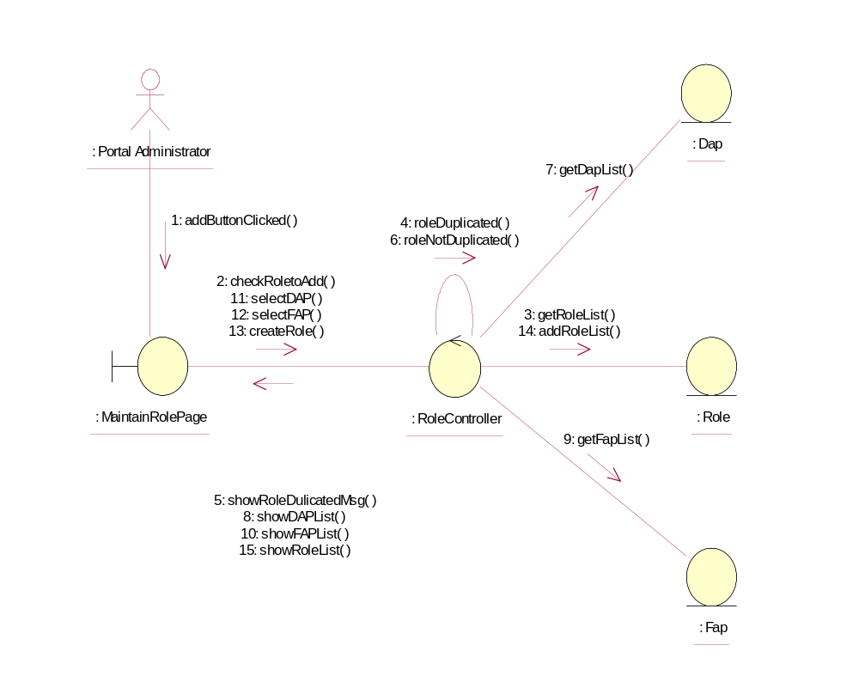

Participating Objects
: DAP
This object shall store the list of the DAP

Role
This object shall store the list of the Role and update the list

FAP
This object shall store the list of the DAP

: RoleController
This Controller shall interface with the boundary to add new role and check for duplicate in the DAPlist, RoleList and FapList.

: MainrainRolePage
This boundary shall display the selection for the actor and to show the warning message of duplication and the list of DAP,FAP and ROLE.

: Portal Administrator
This actor shall perform the necessary action on the boundary.

Class Diagrams

Class Diagram for AddRole
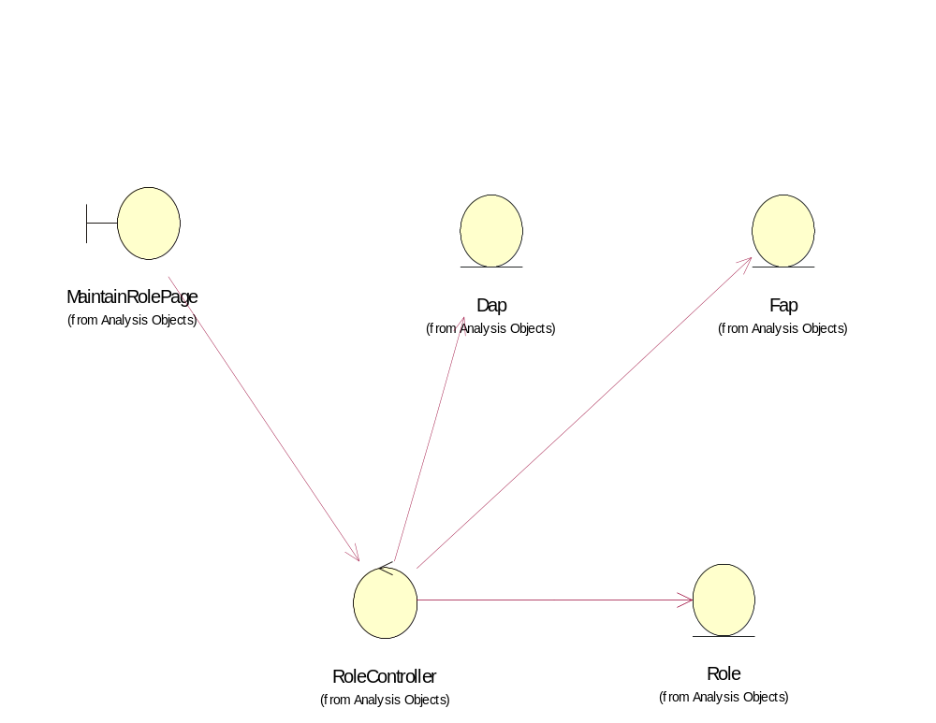

Derived Requirements
Only Portal Administrator has rights to access this page.

